**BUDGET ANALYSIS AND REMINDER**

**INCREMENT #2**

Submitted by

Sandhya Sannapareddy (16181402)

Raghavendra Chirumamilla (16187866)

Haricharana Kanamarlapudi (16186977)

Sampath Madineni (16185610)

* **Objective:** Created an event registration page and after successful registration the details will be saved to database. All the events and budget can be viewed in monthly and yearly basis.
* I**mport Existing API or Services:**

No existing services/API’s used in this project.

* **Detail Design of Services:**
* **User stories using ScrumDo**:

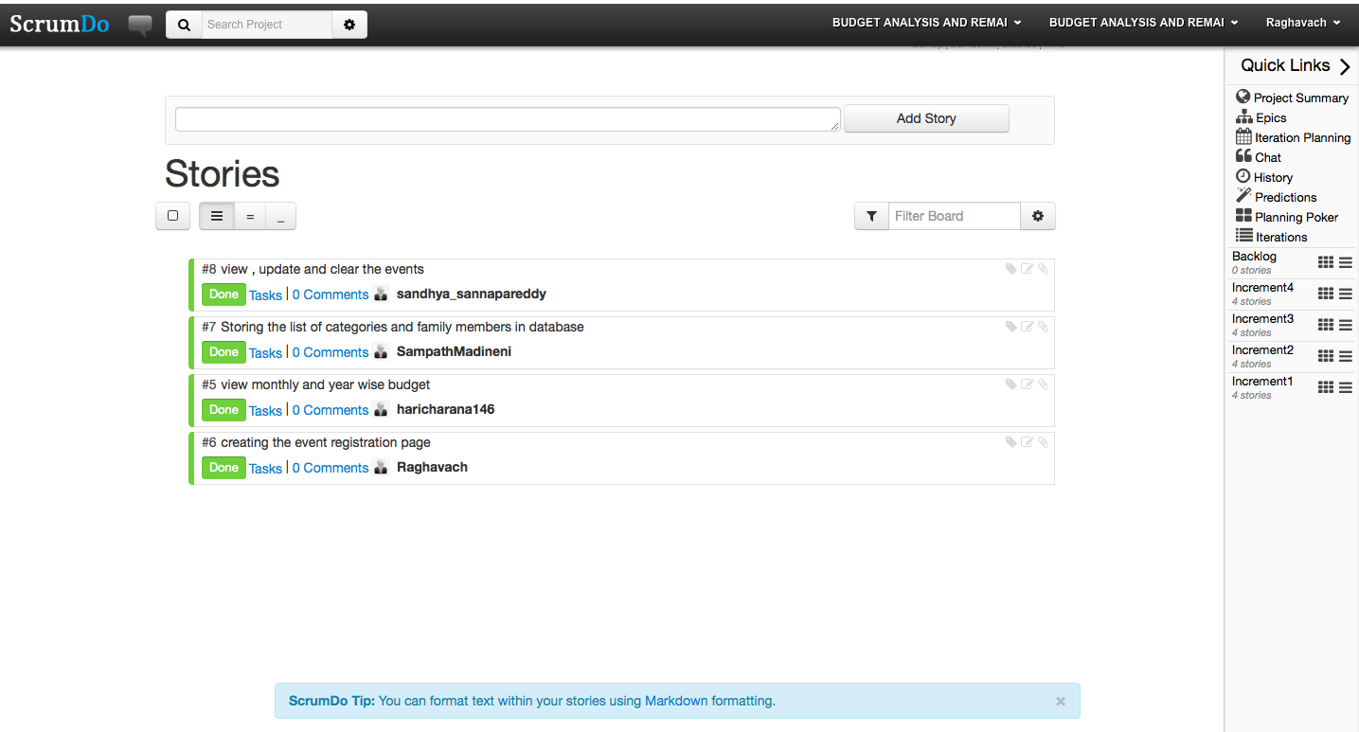

* **Service Description:**
* ***Event registration***:-

Create an event registration form which contain the date you are creating the event, categorize type of event from dropdown list or input text,

Store, update and clear list of events to database, price. And on submit it will saved to database.

* ***View term wise budget***

You can view the total budget in monthly and yearly basis.

* ***View list of events in database***

You can see the events that are previously added in a clear list view.

* **Sequence Diagram**

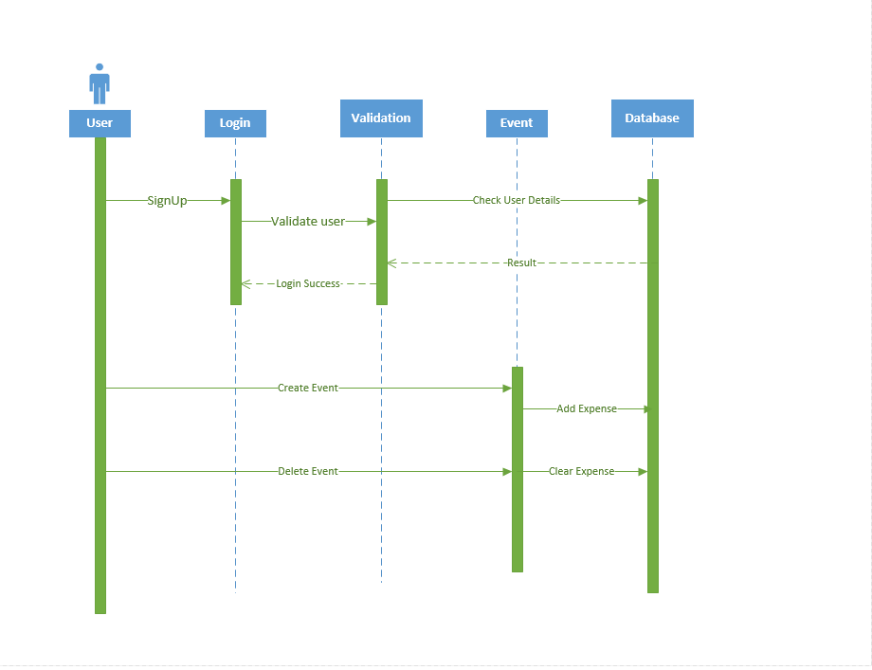

* **Class Diagram**

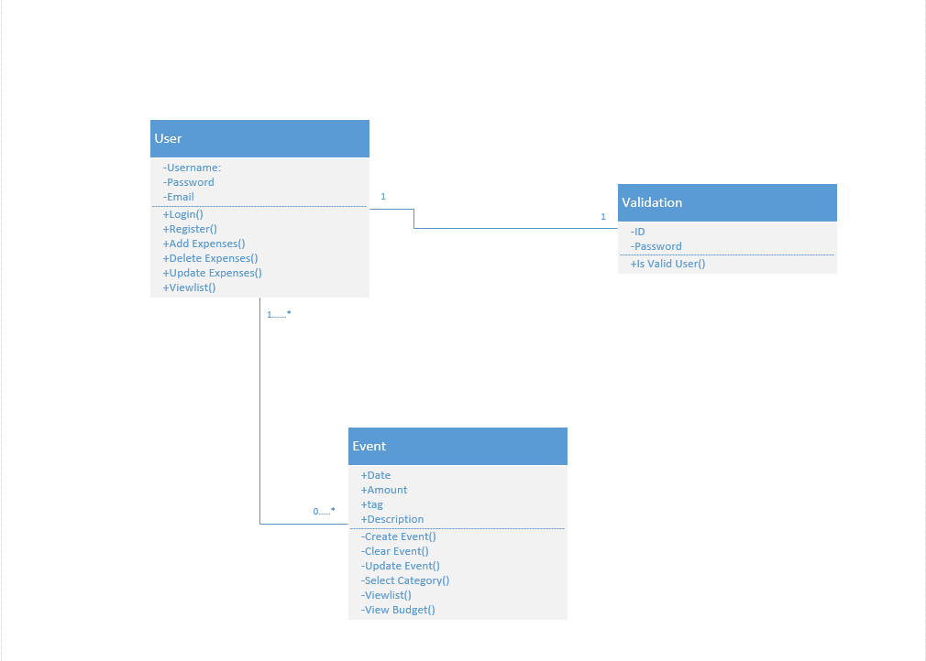

* **Design of Mobile Client Interface:**

Hardware Requirements:

* Dual core processor or 1GHz processor
* SD card – 50 MB
* RAM – 512 MB
* LED screen with touch enabled.

Software Requirements:

* Operating system: Android
* Version: Gingerbread (2.3) or advanced
* **Implementation:**
* Implementation of User Interface:
* After the successfully login into application an event registration page will appeared which contains the date, description, categorize, price fields. And on click on save button the event will be saved to database. On click on clear button all the fields will reset.

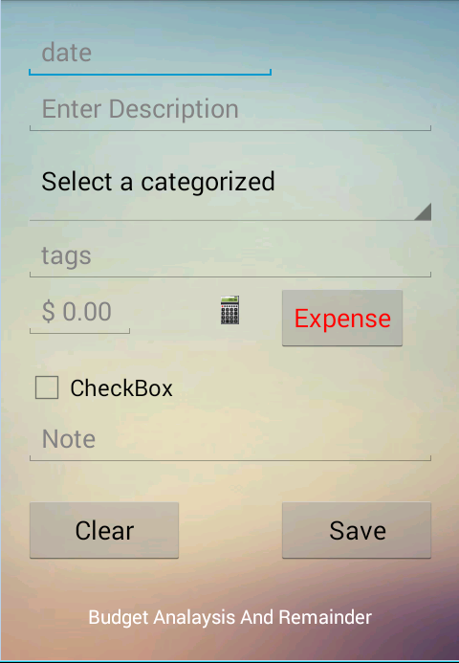

* The date on which you are creating the filled from this display menu

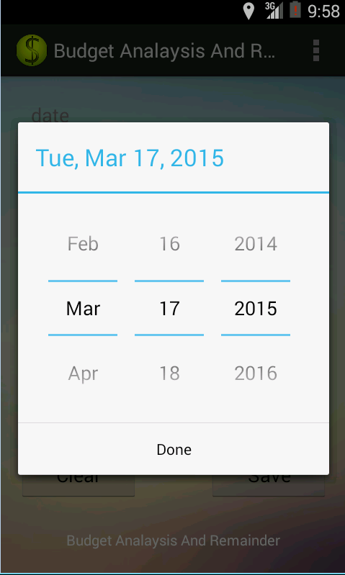

* An user can select the type of event he/she is adding from the dropdown list. He can also add category by typing the text in text field.

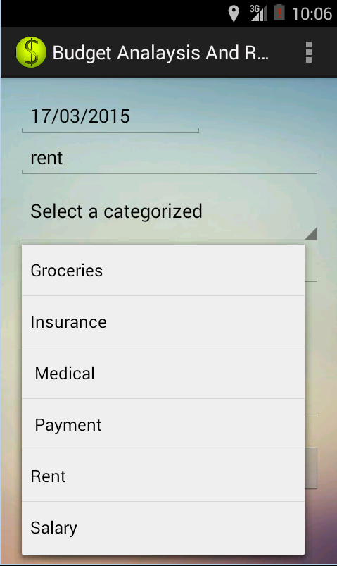

* After entering event details user clicks on submit so that the details will be saved into database.

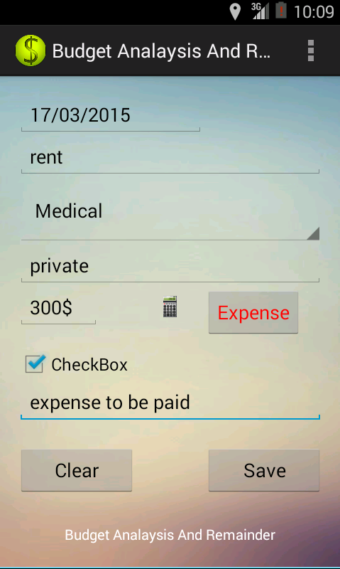

* User can also reset the event registration form if he entered wrong details or if he need it enter new event.

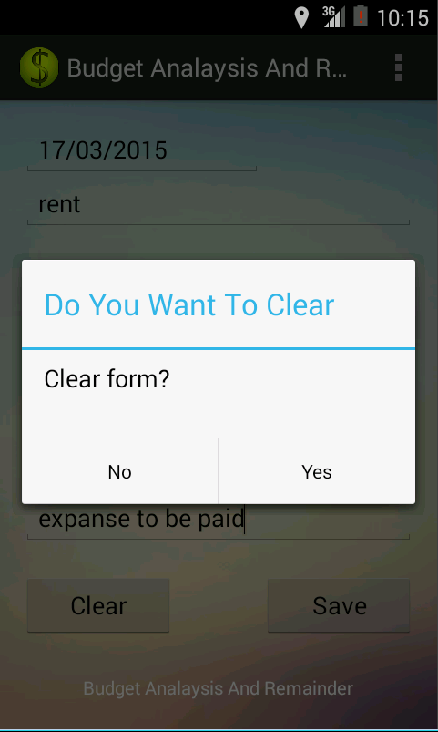

* **Testing:**

Manual testing is performed considering all positive and negative test cases

**Positive test cases**:

* If the user fills all the details and click on save button, the event details will be saved to database and displays a message update successful.



* If the user wants to clear the entered details he clicks on clear button so that it asks for confirmation to clear the event details.



**Negative test cases:**

* If the user keeps any of the field empty and clicks on save button, a dialog box appears showing the message event creation unsuccessful.

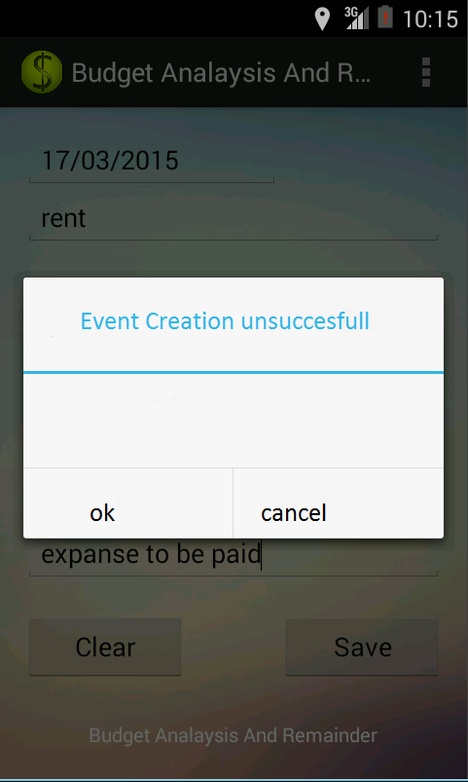

* If the user tries to update the event providing the wrong details such as date, a dialog box appears showing update unsuccessful.
* 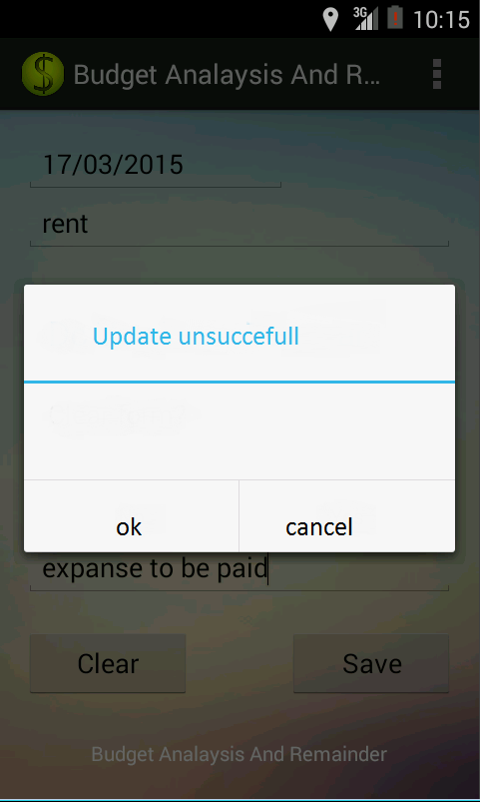
* **Deployment:**
* SrumDo:

<https://www.scrumdo.com/projects/project/budget-analysis-and-remainder1/iteration/121707>

* GitHub:
* **Project Management:**
* **Work completed**:

**Description:**

1. Event registration
2. Storing the list of events and members in the database
3. View list of events stored in database
4. View monthly and annual budget

**Responsibilities:**

*Raghavendra chirumamilla*: created an event registration page, which contain date, description, categories and price fields.

*Sampath Madineni*: on click of save button in registration page the values will be saved into database

*Sandhya sannapareddy*: view, update and clear the list of events in the database

*Hari charana*: view budget details in mothly and yearly wise.

**Time taken**: 2 weeks

**Contributions:**

Raghavendra chirumamilla: 25 %

Sandhya sannapareddy: 25 %

Sampath Madineni: 25 %

Hari charana: 25%

* **Work to be completed:**

No pending work to be done for this increment.

* **Issues/concerns:**

Problems faced during update and storing events to Database.

Generating the list of events.